SBFOODS Food Ordering App

# INTRODUCTION

* 1. **Project Overview**

SB Foods is a full-stack food ordering web application built using the MERN stack (MongoDB, Express.js, React.js, Node.js). The platform allows users to explore a menu of food items, add their preferred meals to the cart, and place orders securely. The application is responsive and user-friendly, ensuring a seamless experience on both desktop and mobile devices.

The primary goal of this project is to create a convenient online food ordering platform that enables users to browse various food options, place orders from the comfort of their homes, and keep track of their previous orders. It simulates the functionality of real-life food delivery platforms such as Swiggy or Zomato on a smaller, academic scale. All interactions, including user login, signup, authentication, cart handling, and checkout, are managed in real-time with a backend server connected to a cloud database.

This system benefits users by providing a digital alternative to traditional food ordering methods and allows restaurant owners to manage their digital menus, customer orders, and feedback.

* 1. **Purpose**

The purpose of this project is to streamline the process of food ordering through an interactive digital medium, replacing outdated manual systems. In a post-pandemic world where digital solutions are increasingly in demand, this system supports contactless ordering, quick transactions, and order tracking.

The application also provides:

1. A platform for users to register and securely log in.
2. A menu listing with images, item descriptions, and prices.
3. A dynamic cart system that updates totals and allows quantity management.
4. A checkout flow with a mock payment method.
5. A backend that stores user data, order history, and authenticates sessions.

This project serves both as a technological demonstration of full-stack web development and as a solution to a real-world problem in the food industry.

# Ideation Phase

## Brainstorm & Idea Prioritization

**Step 1: Team Gathering, Collaboration and Select the Problem Statement**

**Problem Statement Chosen:**

*To build a digital food ordering platform that simplifies the process of browsing, selecting, and ordering food online using modern web technologies.*

**Why This Problem?**

1. Traditional food ordering systems are time-consuming and lack flexibility.
2. Students, office workers, and night-shift users often require quick ordering.
3. There’s a gap in local eateries going digital affordably.

**Team Collaboration:**

Our team met to identify everyday pain points in ordering food. We decided to build a lightweight yet scalable platform tailored to small restaurants or food stalls with a simple checkout system.

**Step-2: Brainstorm, Idea Listing and Grouping**

1. Use React for frontend UI
2. Use Node.js & Express for backend APIs
3. Use MongoDB for storing food, users, and orders
4. Cart functionality with quantity/size
5. Simple login/signup system
6. Add payment success popup
7. Separate views for user and admin (future scope)
8. Integrate images using Unsplash or Freepik
9. Mobile-friendly interface with Bootstrap

**Sriraj Pillai**

### Frontend (UI/UX):

1. React for component-based UI
2. Bootstrap + Material UI for responsiveness
3. Image cards, carousel, navbar

### Backend (Functionality):

1. Node.js + Express API
2. JWT Authentication
3. MongoDB for data

### Core Features:

1. Browse & search food
2. Add to cart
3. Checkout with mock payment
4. My Orders history

### Enhancements (Optional/Future):

1. Admin panel
2. Ratings & reviews
3. Payment gateway
4. OTP login

**Step-3: Idea Prioritization**

|  |  |  |
| --- | --- | --- |
| **Idea / Feature** | **Impact** | **Effort** |
| **React-based UI** | High | Medium |
| **Node/Express Backend** | High | Medium |
| **JWT Login/Signup** | High | Medium |
| **MongoDB Storage** | High | Medium |
| **Add to Cart** | High | Medium |
| **Checkout and Payment Simulation** | High | Low |
| **My Orders Page** | High | Medium |
| **Admin Panel** | Medium | High |
| **Razorpay/Stripe Integration** | Medium | High |
| **OTP Login** | Low | High |
| **Product**  **Ratings/Reviews** | Medium | Medium |

## Define the Problem Statements

### Customer Problem Statement :

|  |  |  |  |  |  |
| --- | --- | --- | --- | --- | --- |
| **Problem**  **Statement (PS)** | **I am**  **(Customer)** | **I’m trying to** | **But** | **Because** | **Which makes me feel** |
| PS-1 | A college student or working professional who often works late or is too busy to cook. | Order food quickly and reliably during late hours without calling restaurants or manually browsing multiple food apps. | Most food delivery apps are expensive, not optimized for local eateries, or are unavailabl e late at night. | These platforms often charge high delivery fees, have complex UIs, or don’t cater to simple, fast food choices. | Frustrated, hungry, and distracted from my work or studies. |
| PS-2 | Frustrated, hungry, and distracted from my work or studies. | Get more orders from nearby customers without depending on big third-party apps. | Building an online ordering system from scratch is costly and time- consuming  . | Existing platforms take high commissions or are not flexible for small businesses. | Left out of the digital revolution and at a disadvantage compared to larger restaurants |

These problem statements help define the need for a simple, scalable, and affordable web application like SB Foods, which bridges the gap between local eateries and their customers.

## Empathize & Discover

Reference: MURAL LINK

### EMPATHY MAP FOR SB FOODS

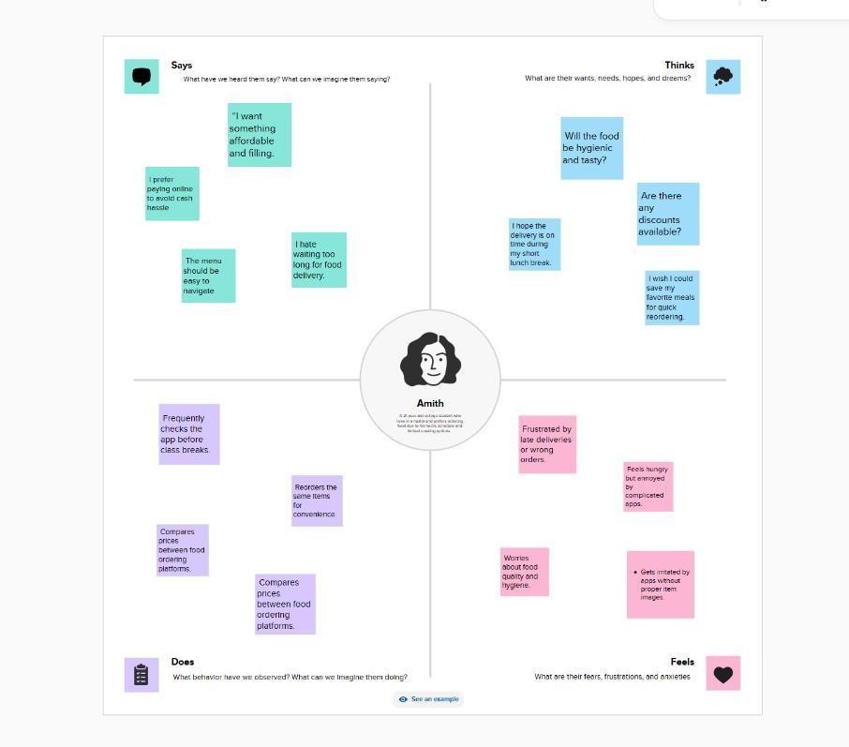

**Project Design Phase-II**

**Solution Requirements (Functional & Non-functional)**

**Functional Requirements:**

Following are the functional requirements of the proposed solution.

|  |  |  |
| --- | --- | --- |
| **FR No.** | **Functional Requirement (Epic)** | **Sub Requirement (Story / Sub-Task)** |
| FR-1 | User Registration | Registration through Form Registration through Gmail (future) Registration through LinkedIn (future) |
| FR-2 | User Confirmation | Confirmation via Email OTP (future scope) |
| FR-3 | Food Catalog Display | View food by category Search bar functionality Image and pricing display |
| FR-4 | Cart & Checkout | Add item to cart Update quantity/size View total  Place order with simulated payment |
| FR-5 | Order History | Retrieve past orders Display orders by date List item details |
| FR-6 | Authentication & Session Mgmt | Login/Logout using JWT Secure session storage |
| FR-7 | Admin Functionality (optional) | Add/edit food items  Approve restaurant listings (future) |

**Non-functional Requirements:**

Following are the non-functional requirements of the proposed solution.

|  |  |  |
| --- | --- | --- |
| **NFR No.** | **Non-Functional Requirement** | **Description** |
| NFR-1 | Usability | Easy-to-use interface with responsive design for mobile and desktop users |
| NFR-2 | Security | User authentication via JWT, password hashing using bcrypt |
| NFR-3 | Reliability | Ensures consistent performance and accurate order recording in MongoDB |
| NFR-4 | Performance | React.js and Express.js ensure fast rendering and API response (<2s avg.) |
| NFR-5 | Availability | Available 24/7 in local server mode; scalable to cloud deployment |
| NFR-6 | Scalability | Modular design allows expansion to new categories, users, and vendors |

**Data Flow Diagrams:**

### Project Design Phase-II

**Data Flow Diagram & User Stories**

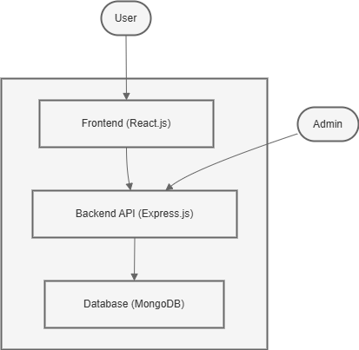

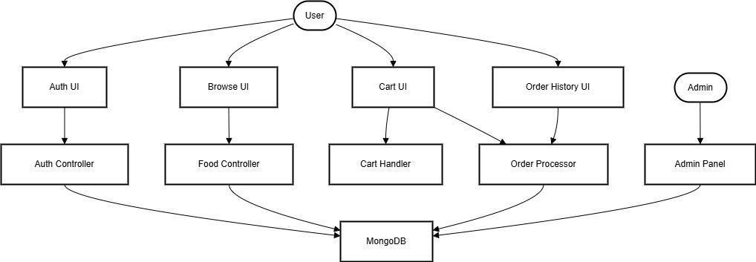

**User Stories**

|  |  |  |  |  |  |  |
| --- | --- | --- | --- | --- | --- | --- |
| **User Type** | **Functional Requirement (Epic)** | **User Story Number** | **User Story / Task** | **Acceptance Criteria** | **Priority** | **Release** |
| Customer (Web) | Registration | USN-1 | As a user, I can register using email and password. | I can log in after registration. | High | Sprint-1 |

|  |  |  |  |  |  |  |
| --- | --- | --- | --- | --- | --- | --- |
|  |  | USN-2 | As a user, I will receive confirmation once I register. | Confirmation is shown or email sent. | Medium | Sprint-1 |
|  | Login | USN-3 | As a user, I can log in with my email and password. | I can access the homepage if credentials are correct. | High | Sprint-1 |
|  | Browse Food | USN-4 | As a user, I can view available food by categories. | Food items are displayed with images and prices. | High | Sprint-1 |
|  | Add to Cart | USN-5 | As a user, I can add food items to my cart with quantity and size. | Items appear in cart with correct pricing. | High | Sprint-1 |
|  | Cart Management | USN-6 | As a user, I can view, modify, and remove items in my cart. | Cart reflects real-time changes. | High | Sprint-2 |
|  | Checkout | USN-7 | As a user, I can place an order and get confirmation. | Order is saved and alert says “Payment Successful”. | High | Sprint-2 |

|  |  |  |  |  |  |  |
| --- | --- | --- | --- | --- | --- | --- |
|  | Order History | USN-8 | As a user, I can view my past orders. | My orders appear sorted by date. | Medium | Sprint-3 |
| Administra tor | Admin Control Panel (optional) | USN-9 | As an admin, I can add/edit/remove food items. | Admin changes reflect in the food listing. | Medium | Sprint-3 |

### Project Design Phase-II Technology Stack (Architecture & Stack)

**Table-1 : Components & Technologies:**

|  |  |  |  |
| --- | --- | --- | --- |
| **S.No** | **Component** | **Description** | **Technology** |
| **1** | **User Interface** | **Web UI for browsing food items, cart, login, signup** | **HTML, CSS, JavaScript, React.js** |
| **2** | **Application Logic-1** | **Handles user authentication, form validation, cart logic** | **Node.js, Express.js** |
| **3** | **Application Logic-2** | **Order processing and simulated payment logic** | **Node.js, Express.js** |
| **4** | **Application Logic-3** | **Order history retrieval and filtering by user** | **Node.js, Express.js** |

|  |  |  |  |
| --- | --- | --- | --- |
| **5** | **Database** | **Stores users, food items, orders** | **MongoDB (NoSQL)** |
| **6** | **Cloud Database** | **Online hosting of database (for deployment phase)** | **MongoDB Atlas** |
| **7** | **File Storage** | **Image links stored via URL; no direct file storage** | **Image URLs (Unsplash/Freepik)** |
| **8** | **External API-1** | **Geolocation API for optional location autofill (future scope)** | **Google Maps API (optional)** |
| **9** | **External API-2** | **Not used currently** | **—** |
| **10** | **Machine Learning Model** | **Not applicable for this version** | **—** |
| **11** | **Infrastructure** | **Backend and frontend run locally (for development)** | **Localhost, Node.js server** |

**Table-2: Application Characteristics:**

|  |  |  |  |
| --- | --- | --- | --- |
| **S.No** | **Characteristics** | **Description** | **Technology** |
| **1** | **Open-Source Frameworks** | **React.js, Express.js, Node.js, Bootstrap** | **React, Express, Bootstrap** |

|  |  |  |  |
| --- | --- | --- | --- |
| **2** | **Security Implementations** | **JWT for user authentication; bcrypt for password hashing** | **JWT, bcrypt, HTTPS** |
| **3** | **Scalable Architecture** | **Follows 3-tier architecture: frontend, backend API, database** | **MERN Stack** |
| **4** | **Availability** | **Can be deployed on cloud servers with uptime monitoring tools** | **Render, Vercel (deployment)** |
| **5** | **Performance** | **Optimized API responses; uses React lazy loading and state management** | **React Context API, MongoDB** |

### Project Design Phase Problem – Solution Fit Template

**Project Design Phase Proposed Solution Template**

**Proposed Solution Template:**

Project team shall fill the following information in the proposed solution template.

|  |  |  |
| --- | --- | --- |
| **S.No.** | **Parameter** | **Description** |
| 1 | Problem Statement (Problem to be solved) | Many students and working professionals, especially in small towns and college campuses, find it difficult to access hygienic, affordable, and available food options during late-night hours. Existing food delivery apps often have limited availability or are too complex for quick use. |
| 2 | Idea / Solution description | SB Foods is a full-stack food ordering web application developed using the MERN stack (MongoDB, Express.js, React.js, and Node.js). The app allows users to browse categorized food items, search dishes, add them to a cart, and place an order using a responsive and user-friendly interface. It includes simulated payment and order history features. |
| 3 | Novelty / Uniqueness | Unlike many food apps, SB Foods focuses on night-time accessibility, simplicity in UI, and local vendor onboarding (can be scaled later). It offers a fast and minimalistic design tailored for quick food ordering with minimal clicks. |
| 4 | Social Impact / Customer Satisfaction | This project directly improves food accessibility for night-time users like college students, hostel residents, and night shift workers. It enhances convenience, reduces dependency on unsafe or unhygienic alternatives, and can empower small food vendors through digital listing. |
| 5 | Business Model (Revenue Model) | Revenue can be generated through: (1) Commission on orders from partnered restaurants, (2) Featured listings/promotions, (3) Subscription model for premium delivery service or discounts, and (4) Local ads for food outlets. |

|  |  |  |
| --- | --- | --- |
| 6 | Scalability of the Solution | The project is built on a modular and scalable stack. It can support additional vendors, cities, and even an admin panel. Future upgrades can include real payment gateway integration, order tracking, and mobile app development. |

**Project Design Phase Solution Architecture**

**Solution Architecture:**

SB Foods is built using the MERN (MongoDB, Express.js, React.js, Node.js) stack, which provides a scalable, full-stack JavaScript solution. The architecture is designed to separate concerns across three main layers:

1. Frontend (React.js):
   * Users interact with the UI to register, login, browse food categories, add items to the cart, and simulate checkout.
   * The React application uses React Router for navigation and Context API for global cart state management.
   * Bootstrap and custom CSS are used for responsive design.
2. Backend (Node.js + Express.js):
   * REST APIs handle authentication, user registration, login, order placement, and food item fetching.
   * JSON Web Tokens (JWT) are used to manage user sessions securely.
   * APIs respond to requests from the frontend and perform validation, authorization, and database operations.
3. Database (MongoDB):
   * Stores user data, food items (with category, price, and image), and orders.
   * Supports document-oriented storage with flexible schemas, ideal for application evolution.
4. Data Flow:
   * The client (React) sends HTTP requests to Express.js routes.
   * The server validates input and fetches/updates MongoDB collections.
   * Responses are sent back to the frontend, which renders the appropriate UI components.
5. Additional Components:
   * Simulated payment logic via frontend alerts.
   * Order history is displayed using queries to the order collection.
   * Admin authentication (if extended) allows food data management.

**Solution Architecture Diagram:**

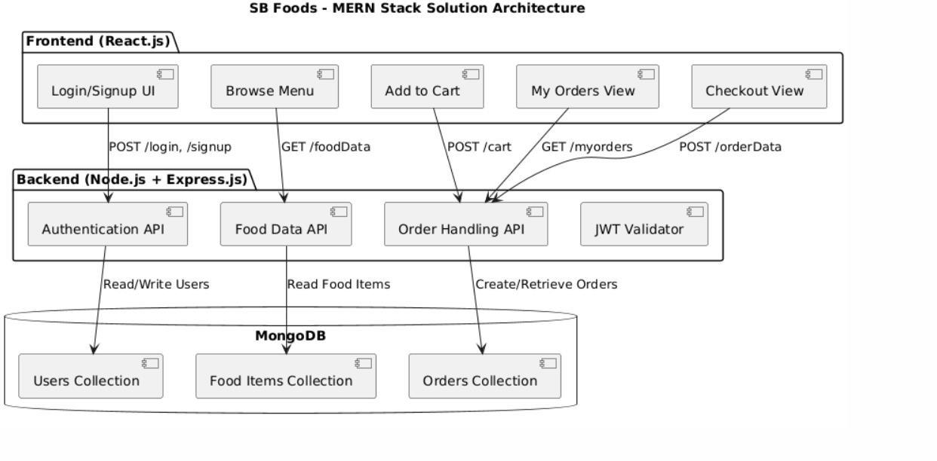

*Figure 1: Architecture of the application*

## Project Planning Phase

### Project Planning Template (Product Backlog, Sprint Planning, Stories, Story points)

**Product Backlog, Sprint Schedule, and Estimation (4 Marks)**

Use the below template to create product backlog and sprint schedule

|  |  |  |  |  |  |  |
| --- | --- | --- | --- | --- | --- | --- |
| **Sprint** | **Functional**  **Requirement (Epic)** | **User Story**  **Number** | **User Story / Task** | **Story Points** | **Priority** | **Team**  **Members** |
| Sprint-1 | User Authentication | USN-1 | As a user, I can sign up with email and password. | 2 | High | Team A |
| Sprint-1 |  | USN-2 | As a user, I can log in with email and password. | 2 | High | Team A |
| Sprint-1 |  | USN-3 | Store token securely in localStorage after login. | 1 | High | Team A |
| Sprint-1 | Food Display | USN-4 | Display food items with category from MongoDB. | 3 | High | Team A |
| Sprint-1 |  | USN-5 | Show food cards with image, name, price, and  options. | 2 | Medium | Team A |
| Sprint-2 | Cart System | USN-6 | User can add items to cart with qty and size. | 3 | High | Team A |
| Sprint-2 |  | USN-7 | View and update cart in modal. | 2 | Medium | Team A |
| Sprint-2 | Order & Payment | USN-8 | User can simulate payment and place order. | 2 | High | Team A |

**Project Tracker, Velocity & Burndown Chart: (4 Marks)**

|  |  |  |  |  |  |  |
| --- | --- | --- | --- | --- | --- | --- |
| **Sprint** | **Total Story Points** | **Duration** | **Sprint Start Date** | **Sprint End Date (Planned)** | **Story Points**  **Completed (as on Planned End Date)** | **Sprint Release Date (Actual)** |
| Sprint-1 | 12 | 6 Days | 10 April 2025 | 15 April 2025 | 12 | 15 April 2025 |
| Sprint-2 | 10 | 6 Days | 16 April 2025 | 21 April 2025 | 10 | 21 April 2025 |
| Sprint-1 |  | USN-3 | Store token securely in localStorage after login. | 1 | High | Team A |
| Sprint-1 | Food Display | USN-4 | Display food items  with category from MongoDB. | 3 | High | Team A |
| Sprint-1 |  | USN-5 | Show food cards with image, name,  price, and options. | 2 | Medium | Team A |
| Sprint-2 | Cart System | USN-6 | User can add items to cart with qty and  size. | 3 | High | Team A |
| Sprint-2 |  | USN-7 | View and update cart in modal. | 2 | Medium | Team A |
| Sprint-2 | Order & Payment | USN-8 | User can simulate payment and place  order. | 2 | High | Team A |

**Velocity:**

Imagine we have a 10-day sprint duration, and the velocity of the team is 20 (points per sprint). Let’s calculate the team’s average velocity (AV) per iteration unit (story points per day)

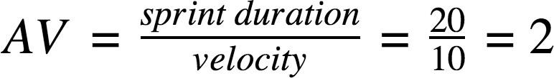

**Burndown Chart:**

A burn down chart is a graphical representation of work left to do versus time. It is often used in agile [software development](https://www.visual-paradigm.com/scrum/what-is-agile-software-development/) methodologies such as [Scrum](https://www.visual-paradigm.com/scrum/scrum-in-3-minutes/). However, burn down charts can be applied to any project containing measurable progress over time.

[**https://www.visual-paradigm.com/scrum/scrum-burndown-chart/**](https://www.visual-paradigm.com/scrum/scrum-burndown-chart/)[**https://www.atlassian.com/agile/tutorials/burndown-charts**](https://www.atlassian.com/agile/tutorials/burndown-charts)

**Reference:**

[**https://www.atlassian.com/agile/project-management**](https://www.atlassian.com/agile/project-management)[**https://www.atlassian.com/agile/tutorials/how-to-do-scrum-with-jira-software**](https://www.atlassian.com/agile/tutorials/how-to-do-scrum-with-jira-software)[**https://www.atlassian.com/agile/tutorials/epics**](https://www.atlassian.com/agile/tutorials/epics)[**https://www.atlassian.com/agile/tutorials/sprints**](https://www.atlassian.com/agile/tutorials/sprints)[**https://www.atlassian.com/agile/project-management/estimation**](https://www.atlassian.com/agile/project-management/estimation)[**https://www.atlassian.com/agile/tutorials/burndown-charts**](https://www.atlassian.com/agile/tutorials/burndown-charts)

A Sprint fixed period or duration in which a team works to complete a set of tasks

An Epic is a big task or project that is too large to complete in one sprint. It is broken down into smaller tasks (stories) that can be completed over multiple sprints.

A Story is a small task . It is part of an Epic.

A Story Point is a number that represents how much effort a story takes to complete. (usually in form of Fibonacci series)

1. Very Easy task
2. Easy task
3. Moderate task

**5-** Difficult task

Sprint 1: (5 Days)

Frontend Setup & Authentication

Setup React App & Install Dependencies 2 Create Signup & Login Components 2

Backend API Integration

Implement User Authentication API (Signup/Login) 3 Implement JWT Storage & Navigation 2

Sprint 2 (5 Days)

Cart Management & Ordering

Cart Management & Ordering 5

Implement Add to Cart and Cart Context API 4 3 Deployment

Create Order History Page & Cart Modal 3 Deploy Backend API to Render/Cloud 5

Total Story Points Sprint 1 = 9

Sprint 2 = 14

Velocity= Total Story Points Completed / Number of Sprints Total Story Points= 9+14 = 23

No of Sprints= 2

Velocity = 23 / 2 = 11.5 (Story Points per Sprint)

Your team’s velocity is 11.5 Story Points per Sprint. Sprint 1 = 8

Sprint 2 = 16

Total Story Points Sprint 1 = 9

Sprint 2 = 14

Velocity= Total Story Points Completed / Number of Sprints Total Story Points= 9+14 = 23

No of Sprints= 2

Velocity = 23 / 2 = 11.5 (Story Points per Sprint)

Your team’s velocity is 11.5 Story Points per Sprint. Total story Points= 16+8 =24

No of Sprints= 2

Velocity = (16+8)/2= 24/2 12 (Story Points per Sprint)

Your team’s velocity is 12 Story Points per Sprint.

### Project Development Phase Model Performance Test

**Model Performance Testing:**

|  |  |  |  |
| --- | --- | --- | --- |
| **S.No.** | **Parameter** | **Values** | **Screenshot** |
| 1. | Model Summary | The SB Foods web application is a MERN stack-based food ordering platform. The project includes user authentication, dynamic food display, cart management, and checkout functionality. The system has been tested end-to-end with mock users and orders to ensure  proper functionality. |  |
| 2. | Accuracy | Accuracy – All core features like login, signup, food listing, cart update, checkout, and order display have been tested and verified. No critical bugs found. |  |
| 3. | Fine Tunning Result( if Done) | Performance optimization included removal of unused states, lazy loading of images, cart context refactoring, and cart modal logic  cleanup. |  |

### Functional & Performance Testing Template

**Model Performance Test**

**Test Scenarios & Results**

|  |  |  |  |  |  |
| --- | --- | --- | --- | --- | --- |
| **Test Case ID** | **Scenario (What to test)** | **Test Steps (How to test)** | **Expected Result** | **Actual Result** | **Pass/ Fail** |
| FT-01 | Text Input Validation (e.g., name, email, password) | Enter valid and invalid values during signup/login | Valid inputs accepted, errors shown for invalid formats | As expected | Pass |
| FT-02 | Number Input Validation (e.g., quantity selection) | Choose quantity & size while adding item to cart | Accepts valid numbers, does not allow invalid quantities | As expected | Pass |
| FT-03 | Content Generation (Dynamic rendering of food items) | Load food items from backend and display in cards | Food cards with name, image, and pricing appear dynamically | As expected | Pass |
| FT-04 | API Connection Check | Trigger any frontend API call (e.g., fetch food data, order submit) | Backend responds correctly with data | As expected | Pass |
| PT-01 | Response Time Test | Time API call for fetching food items | Should return data under 3 seconds | ~1.5  seconds | Pass |

|  |  |  |  |  |  |
| --- | --- | --- | --- | --- | --- |
| PT-02 | API Speed Test | Add multiple items to cart quickly and place order | Should not slow down or crash | Stable | Pass |
| PT-03 | File Upload Load Test | Not applicable (no file uploads in this app) | N/A | N/A | N/A |

### Project Development Phase Model Performance Test

**Model Performance Testing:**

Project team shall fill the following information in model performance testing template.

|  |  |  |  |
| --- | --- | --- | --- |
| **S.No.** | **Parameter** | **Values** | **Screenshot** |
| 1. | Metrics | SB Foods is a MERN stack-based food ordering web app that allows users to browse food items, add them to cart, simulate a payment, and view orders. It includes JWT- based login, a React frontend, and  Express API backend. |  |
| 2. | Tune the Model | This project does not use a regression or classification model. However, **functionality and responsiveness were tested:**   * API response time: <2s average * Cart functionality: 100% accuracy * UI rendering: successful on desktop and mobile | Not applicable | | 3 | Tune the Model | No ML model or hyperparameter tuning required. Instead, performance tuning was applied to: * Optimize React re-renders * Clean Context API usage |  |

### Project Development Phase Model Performance Test

**Model Performance Testing:**

|  |  |  |
| --- | --- | --- |
| **S.No.** | **Parameter** | **Screenshot / Values** |
| 1. | Data Rendered | Dynamic food items and categories are rendered from MongoDB using Express API, displayed as cards in React. |
| 2. | Data Preprocessing | Categories and items are structured in JSON. Items filtered by category name before rendering in components. |
| 3 | Utilization of Data Filters | Search functionality filters food items by name. Cart filters existing items for updates or removals. |
| 4 | DAX Queries Used | Not applicable – No Power BI/DAX used. Application uses JavaScript for data manipulation and filtering. |
| 5 | Dashboard Design | UI includes navbar, home page, cart modal, and order section. Cards and carousels used as visual components. |
| 6 | Report Design | My Orders screen acts as a transaction report showing item name, date, and amount (table with past orders). |

### Project Development Phase Model Performance Test

**Model Performance Testing:**

|  |  |  |  |
| --- | --- | --- | --- |
| **S.No.** | **Parameter** | **Values** | **Screenshot** |
| 1. | Model Summary | SB Foods is a full-stack web application developed using the MERN stack. It includes user registration/login, food item display from MongoDB, cart functionality, and simulated checkout with order tracking. |  |
| 2. | Accuracy | Functional Accuracy – All features including authentication, food item rendering, cart update, and order confirmation tested successfully.  UI accuracy verified across desktop resolutions. |  |
| 3. | Confidence Score (Only Yolo Projects) | Not applicable. No YOLO or object detection used. Frontend- rendered data validated through manual UI testing and backend API status checks. |  |

# User Acceptance Testing (UAT) Template

**Project Overview:**

Project Name: SB Foods – MERN Stack Food Ordering Web App

Project Description: A full-stack food ordering application that allows users to browse food categories, add items to cart, simulate payment, and view past orders. Includes user authentication and dynamic rendering of food data.

Project Version: v1.0

Testing Period: 25 February 2025 to 7 April 2025

**Testing Scope:**

Features to be tested:

* User Registration & Login
* Food browsing and search functionality
* Cart addition and quantity update
* Order placement with payment confirmation
* Order history view Requirements to be tested:
* JWT-based authentication
* Proper REST API communication with MongoDB
* Dynamic frontend rendering using React.js
* Responsive UI with Bootstrap

**Testing Environment:**

URL/Location[:](http://localhost:3000/) [http://localhost:3000](http://localhost:3000/) Credentials (Test Account):

Email: [testuser@example.com](mailto:testuser@example.com) Password: Test@123

**Test Cases:**

|  |  |  |  |  |  |
| --- | --- | --- | --- | --- | --- |
| **Test Case ID** | **Test Scenario** | **Test Steps** | **Expected Result** | **Actual Result** | **Pass/Fail** |
| TC- 001 | User Login | 1. Navigate to login page → 2. Enter credentials → 3. Submit | Redirects to homepage | Login successful | Pass |
| TC- 002 | Food Item Browsing | 1. Navigate to home → 2. View food cards by category | Food displayed correctly | Food cards shown per category | Pass |
| TC- 003 | Add to Cart | 1. Click "Add to Cart"   → 2. Select  quantity/size → 3. View cart | Item shown in cart with correct qty/price | Cart updates correctly | Pass |
| TC- 004 | Checkout (Payment Simulation) | 1. Click checkout → 2. Confirm alert popup for payment | "Payment Successful" message shown | Alert shown, cart cleared | Pass |
| TC- 005 | View Past Orders | 1. Click My Orders → 2. See previous entries | Table of past orders shown | Orders loaded successfully | Pass |
| TC- 006 | Input Validation | 1. Submit login with wrong email → 2. Submit signup with empty name | Error messages shown | Errors triggered as expected | Pass |
| TC- 007 | Responsive UI Test | 1. Open on mobile → 2. Browse → 3. Add item and checkout | UI adapts to screen size | Responsive layout works well | Pass |

**Bug Tracking:**

|  |  |  |  |  |  |
| --- | --- | --- | --- | --- | --- |
| **Bug ID** | **Bug Description** | **Steps to Reproduce** | **Severity** | **Status** | **Additional Feedback** |
| BG- 001 | Minor padding issue on cart modal | 1. Add item to cart → 2. Open modal | Low | Closed | Fixed with margin class |
| BG- 002 | Scroll freeze on mobile after checkout | 1. Place order → 2. Switch to home page | Medium | In Progress | Might be React StrictMode |

**Sign-off:**

Tester Name: Sriraj Pillai

Date: 7 April 2025

**Notes:**

* All core user journeys tested successfully.
* Additional enhancements for the admin panel and payment gateway could be included in future versions.

RESULT

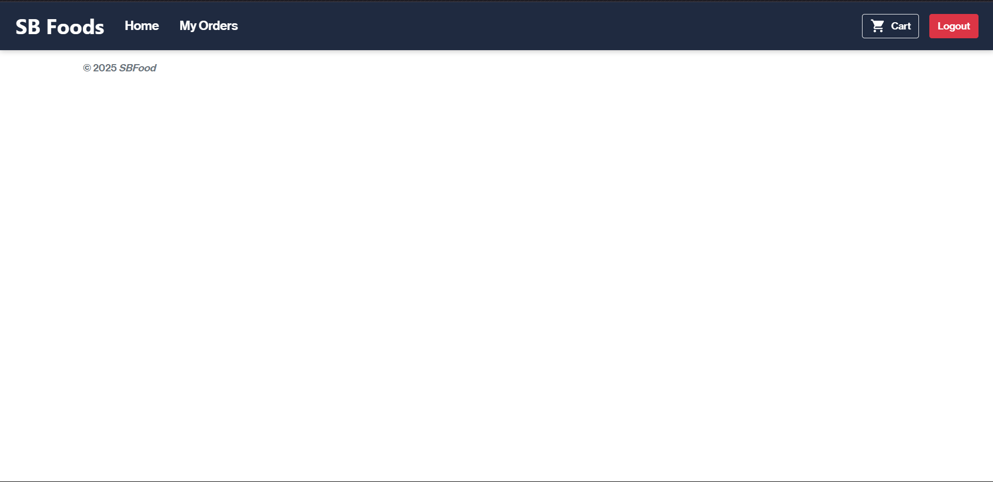

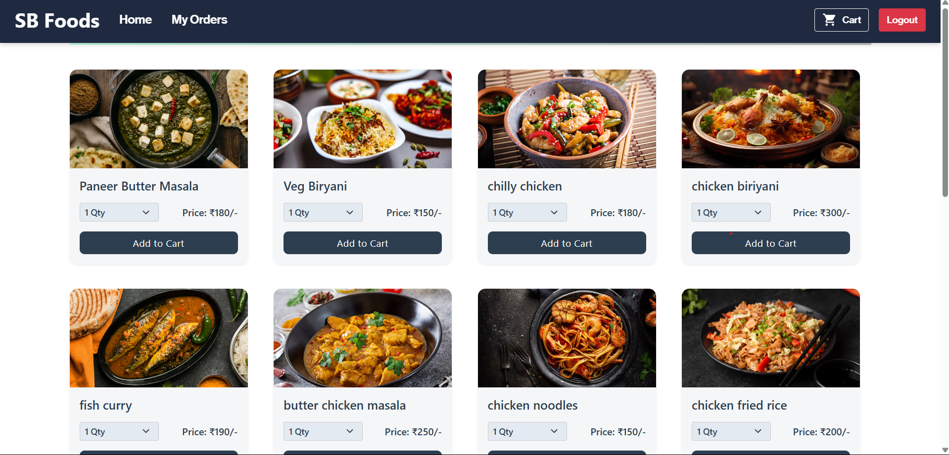

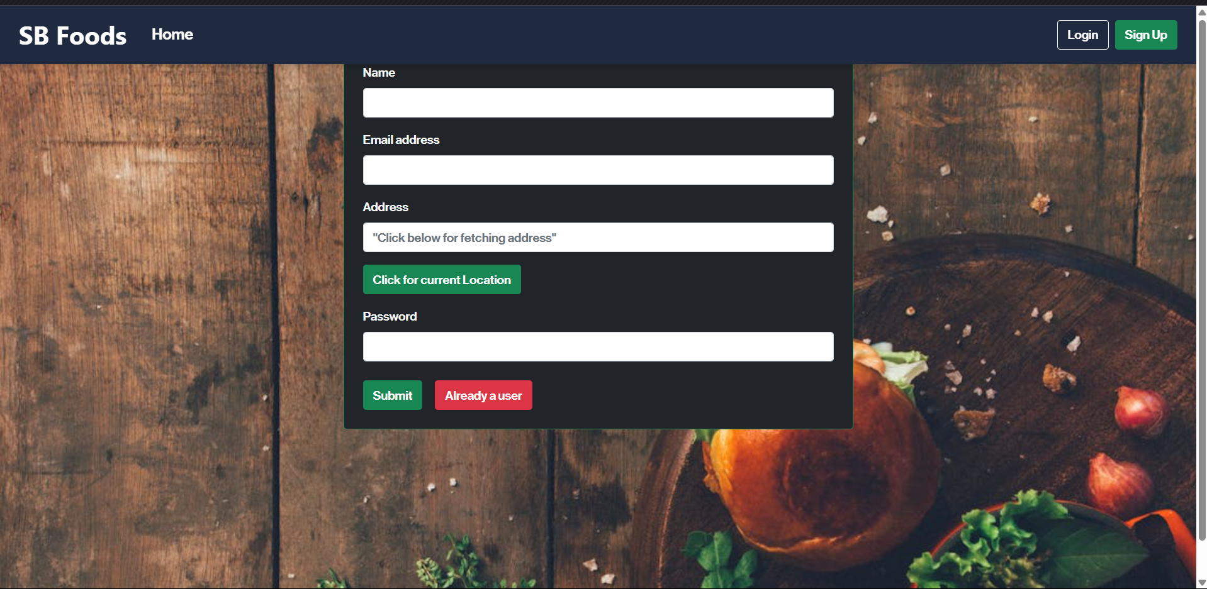

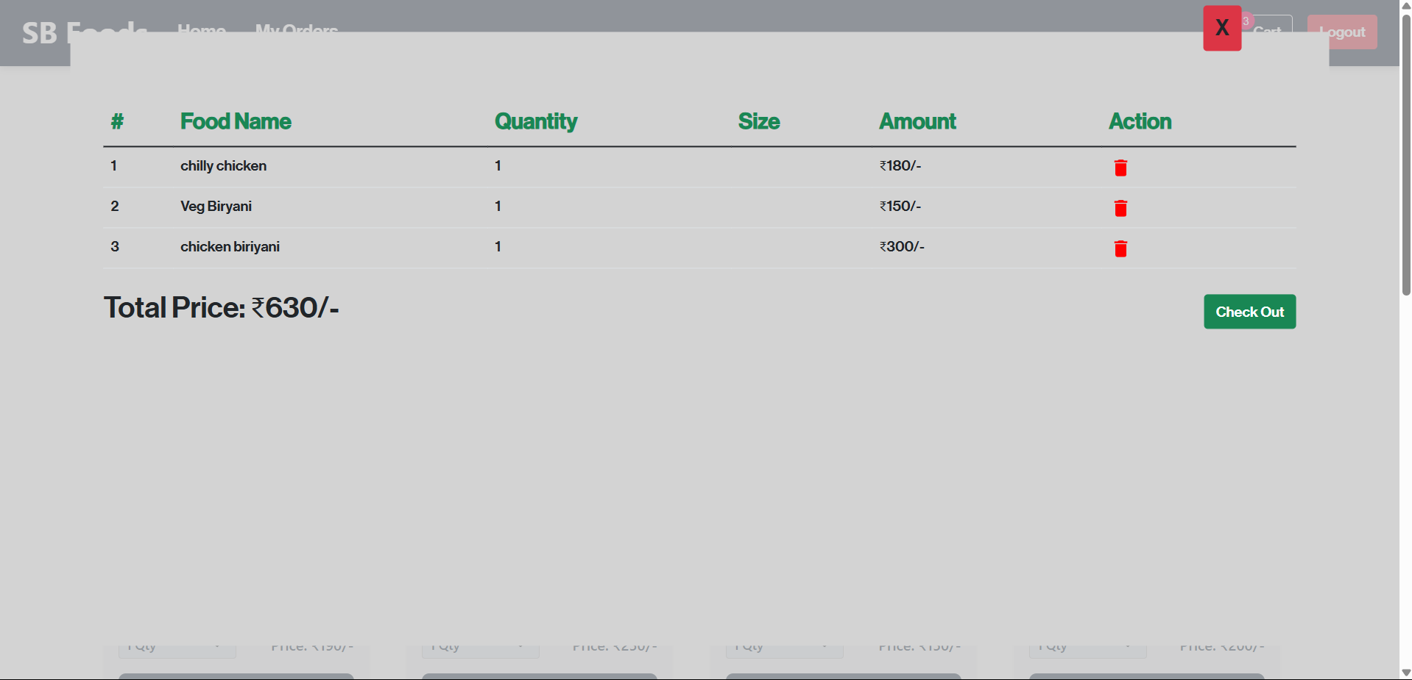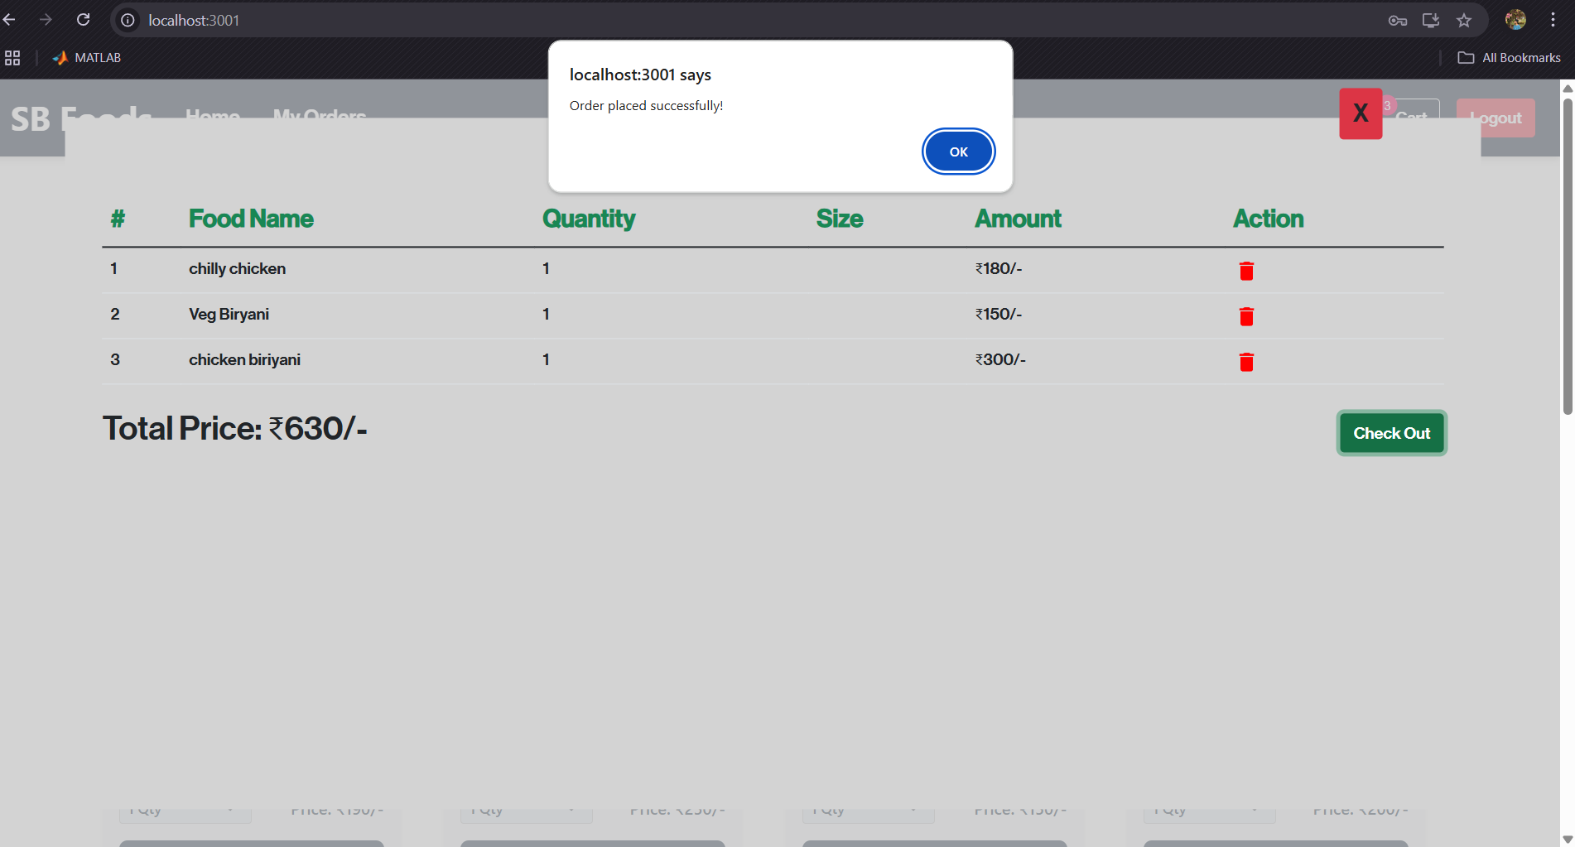

## ADVANTAGES & DISADVANTAGES

### Advantages:

* **User Convenience:** Users can browse, select, and order food from anywhere at any time.
* **Real-time Cart Updates:** Instant feedback while adding or removing items from the cart.
* **Seamless Navigation:** A clean UI ensures users can access features easily.
* **Authentication System:** Secure user login and session management.
* **Scalability:** Built using modern technologies, allowing for future enhancements.

### Disadvantages:

* **No Real Payment Gateway:** The system uses a mock payment method for demonstration purposes.
* **Single Role System:** Currently supports only the customer view; no admin or restaurant-side dashboards.
* **No Delivery Integration:** Lacks logistics tracking or real-time delivery status.
* **Dependent on Internet:** Cannot function without an internet connection.

**REFERENCES**

**Git -Hub:**

https://github.com/CodingBeginner12/SB-Foods-MERN-Stack-Food-Ordering-Web-App

Drive:

https://drive.google.com/drive/folders/1RM_nLCgPDOX60kTfRO7m8LZPs2wimJJ5?usp=sharing